EXPT NO: 8 | GENERATION OF SYNTHETIC IMAGES USING A GENERATIVE ADVERSARIAL NETWORK (GAN)
DATE: 31-10-26

PRE-LAB QUESTIONS

1. Discuss the roles of the Generator and Discriminator in a GAN.

The Generator and Discriminator are the two main components of a Generative Adversarial Network. The Generator creates synthetic images using random noise as input. The Discriminator examines images and classifies them as real or fake. Both networks are trained together to improve their performance. The Generator tries to fool the Discriminator by producing realistic images.

2. Explain how a Generator produces synthetic images from random noise.

The Generator takes a random noise vector as its input to create synthetic images. It passes the noise through multiple neural network layers to learn image patterns. These layers transform the random values into meaningful visual features. The final layer produces an image with the required dimensions and pixel values. Through training, the Generator learns to create images that resemble real dataset images.

3. Why is adversarial training important in a GAN?

Adversarial training helps the Generator and Discriminator improve through competition. The Generator tries to generate realistic images that can fool the Discriminator. The Discriminator learns to distinguish real images from generated images. Both networks continuously update their parameters based on their errors. This process helps the Generator produce increasingly realistic synthetic images.

4. Discuss the significance of the loss functions used to train the Generator and Discriminator.

Loss functions measure the errors made by the Generator and Discriminator during training. The Generator loss indicates how well it fools the Discriminator. The Discriminator loss measures its ability to identify real and fake images correctly. These losses guide the networks in updating their weights through backpropagation. Proper loss functions help maintain stable training and improve image generation quality.

AIM
To implement and train a Generative Adversarial Network (GAN) to generate synthetic images by training a Generator and a Discriminator in an adversarial learning framework.

SOFTWARE REQUIREMENTS
- Python
- TensorFlow / Keras / PyTorch
- Google Colab
- GitHub
- NumPy
- Matplotlib
- Pandas
- Scikit-learn

OBJECTIVES
Students will be able to:
- Understand the architecture and working of Generative Adversarial Networks.
- Identify the functions of the Generator and Discriminator.
- Prepare image datasets for GAN training.
- Generate random noise vectors as inputs to the Generator.
- Build and train a simple GAN using a suitable dataset.
- Understand adversarial training and the associated loss functions.
- Generate synthetic images and visualize the results.
- Evaluate the quality and diversity of generated images through visual inspection.
- Document the experiment and manage the notebook using GitHub.

PROCEDURE
PART A: DATASET PREPARATION
Perform the following tasks:
- Load an image dataset, such as MNIST, and display sample images.
- Explore the image dimensions and pixel-value range.
- Normalize and reshape the images according to the GAN input requirements.
- Prepare batches of real images for training.
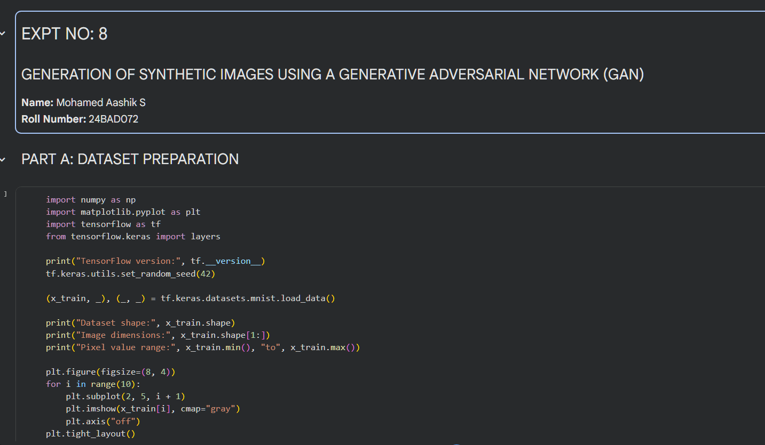
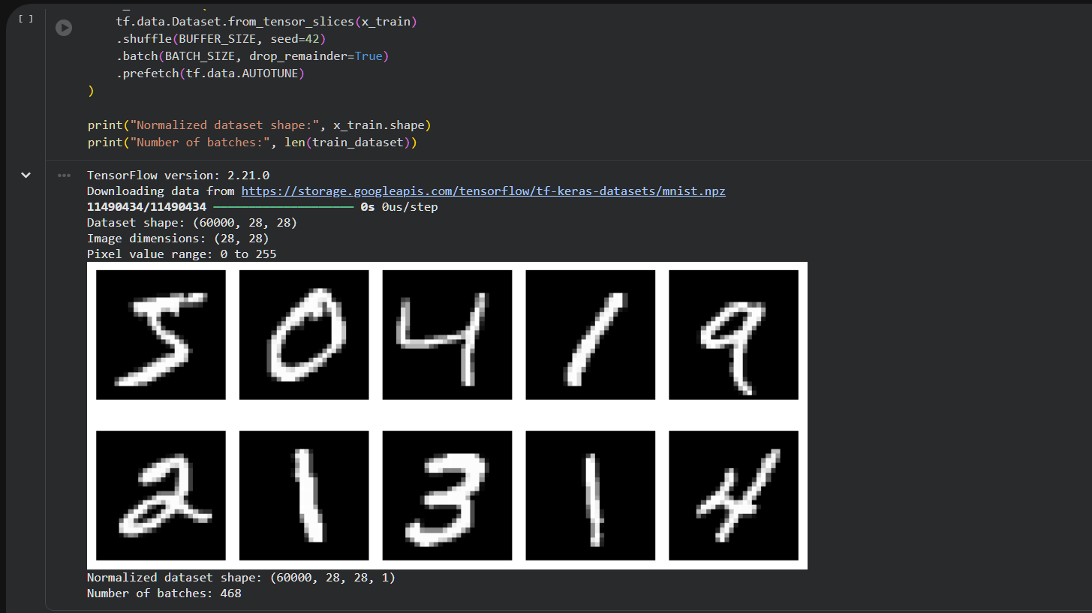

PART B: IMPLEMENTING THE THE GENERATOR AND DISCRIMINATOR
Perform the following tasks:
- Build a Generator model to create synthetic images from random noise vectors.
- Build a Discriminator model to classify images as real or generated.
- Select suitable layers, activation functions, optimizer, and loss function.
- Combine the Generator and Discriminator to construct the GAN.
- Display the model summaries.

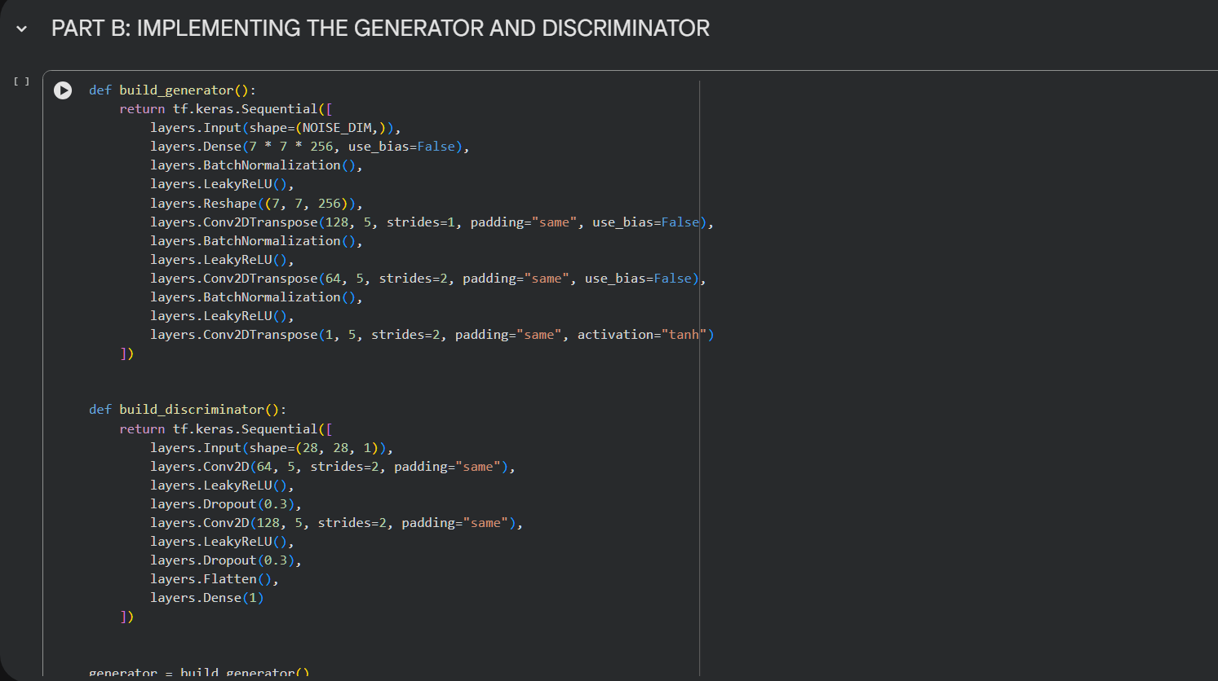
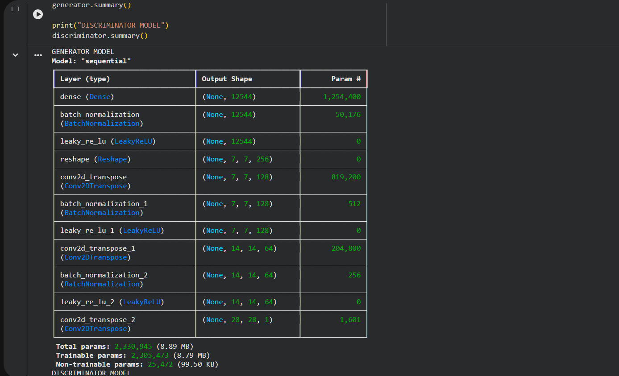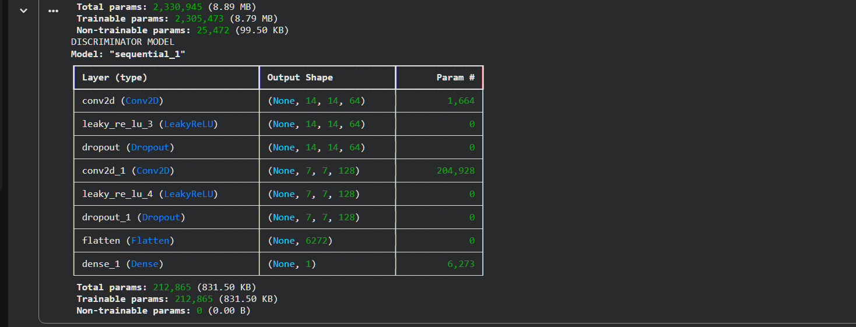

PART C: GAN TRAINING AND PERFORMANCE MONITORING

Perform the following tasks:
- Train the Discriminator using real and generated images.
- Train the Generator to produce realistic images.
- Alternate the training of both models for a suitable number of epochs.
- Record and plot Generator and Discriminator losses.
- Display sample generated images during training.
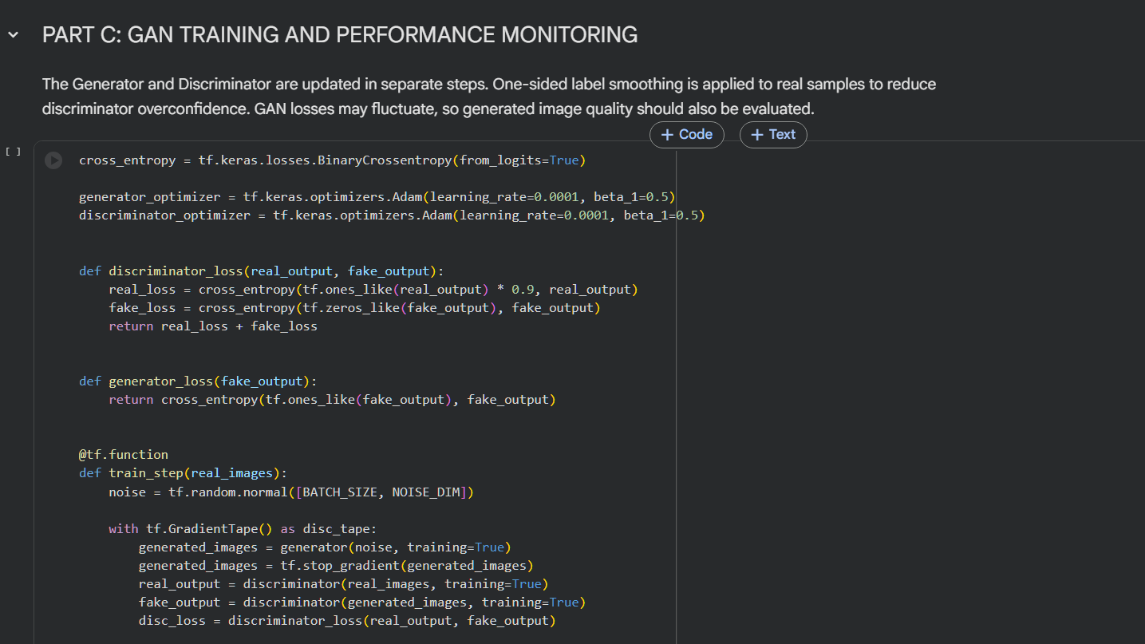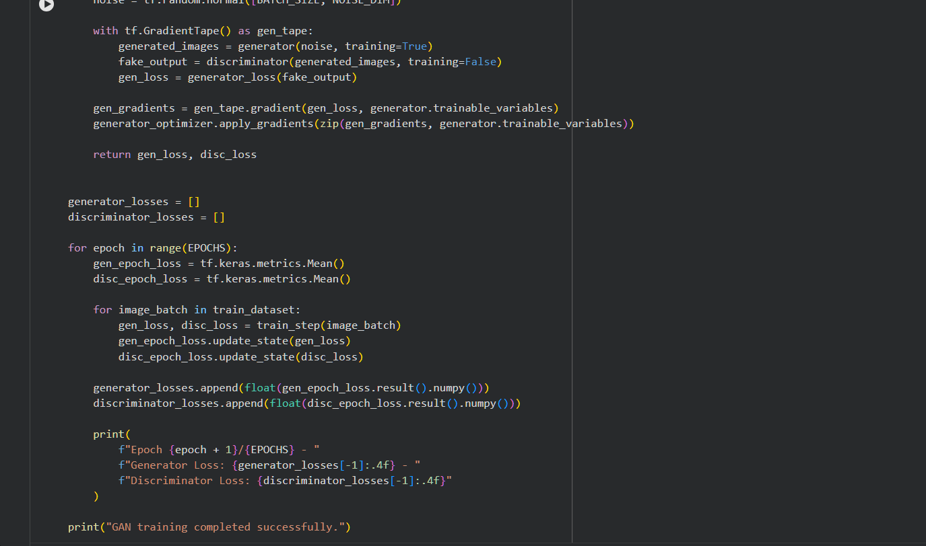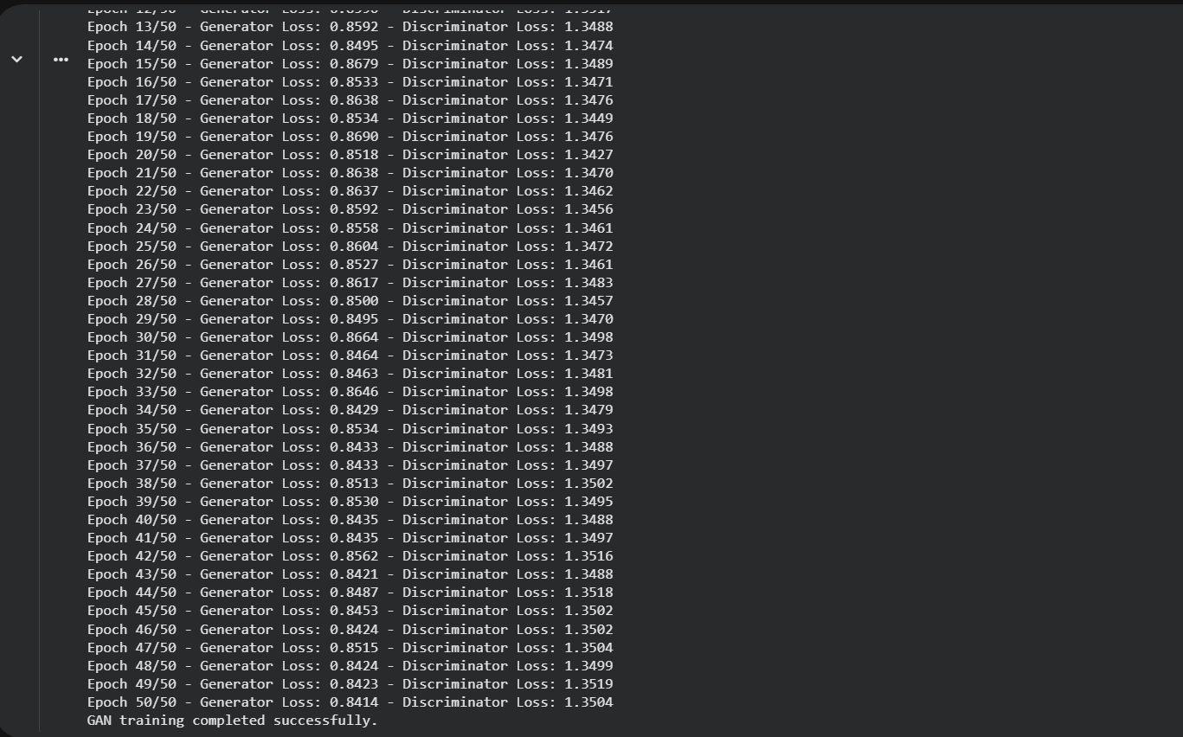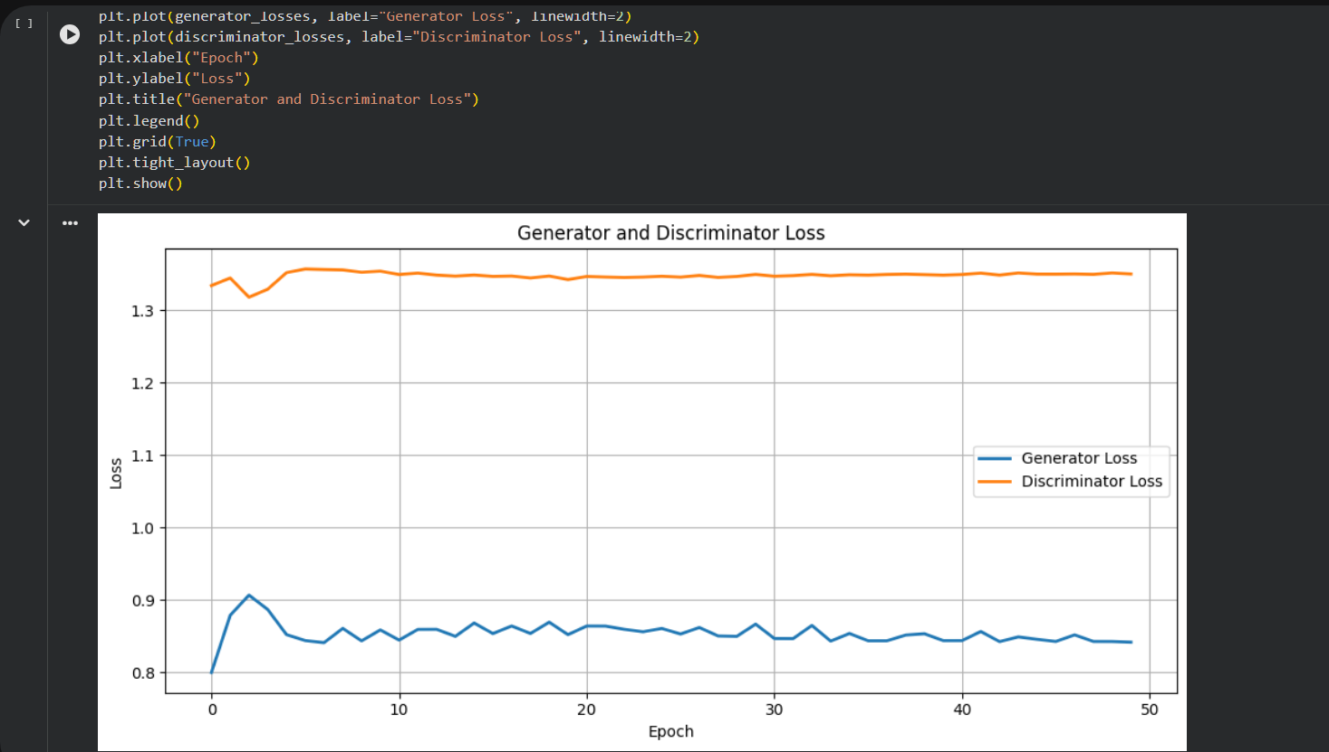

PART D: DIMENSIONALITY REDUCTION, FEATURE VISUALIZATION AND EXPERIMENT MANAGEMENT

Perform the following tasks:
- Provide new movie-review sentences as input to the trained LSTM model.
- Extract latent-space representations of test samples using the trained Encoder.
- Generate synthetic images using the trained Generator.
- Display and compare generated images with original dataset samples.
- Observe the quality, diversity, and recognizability of generated images.
- Document the experiment and upload the notebook to GitHub.
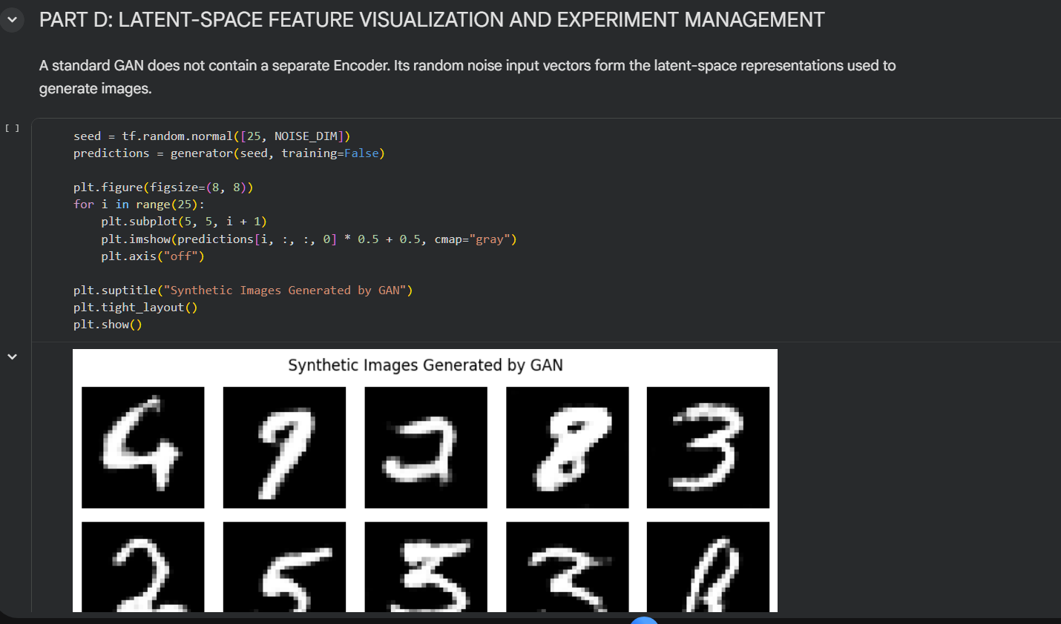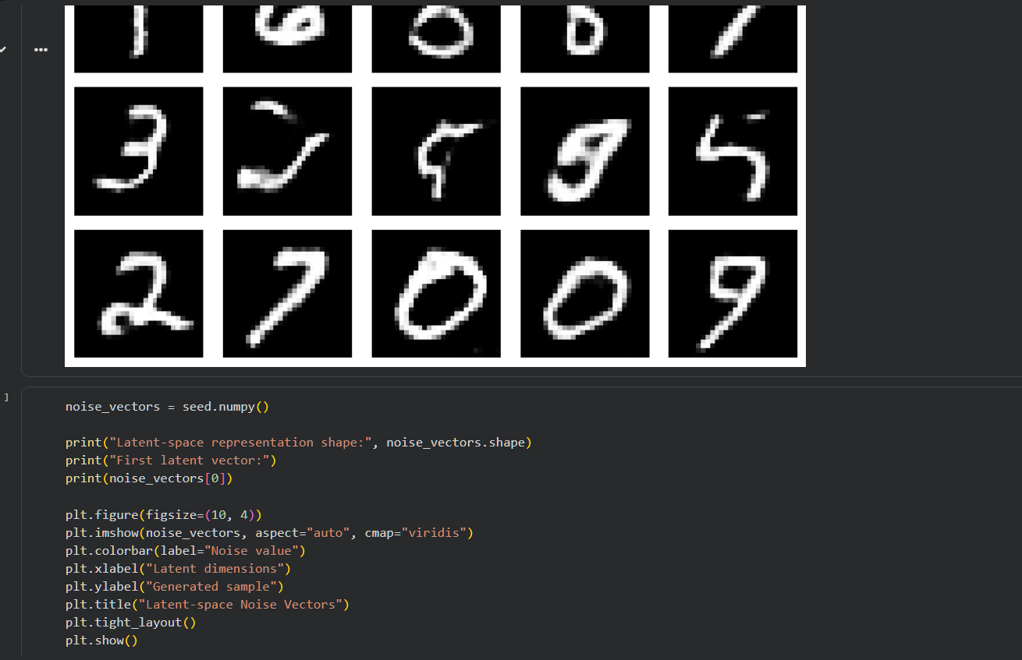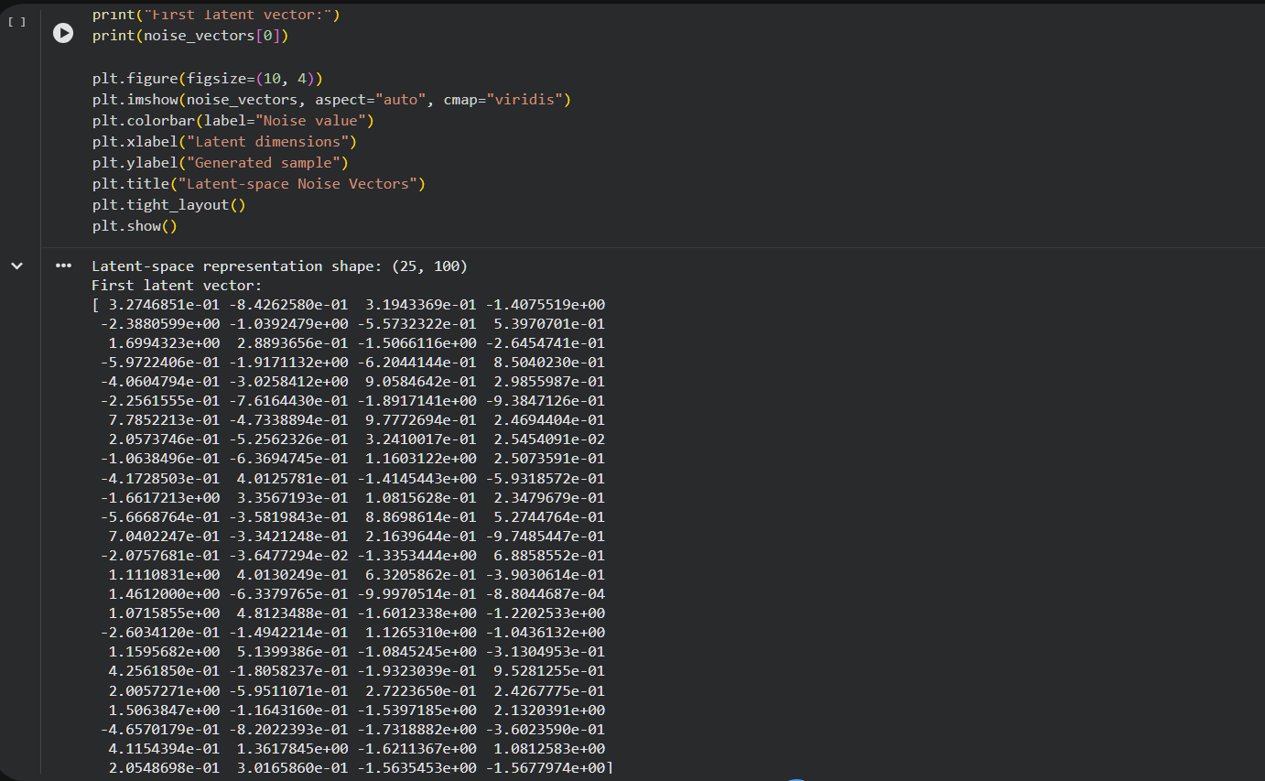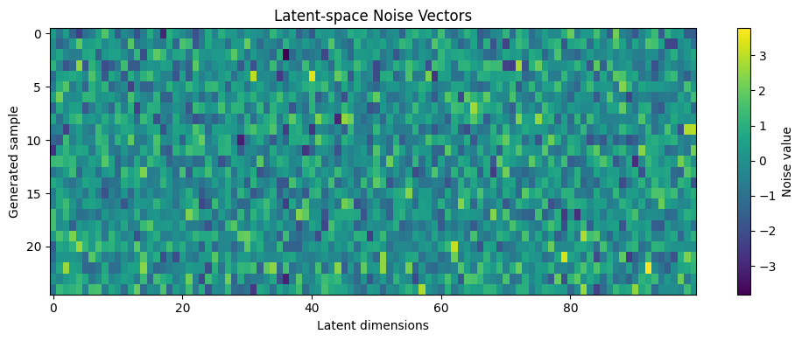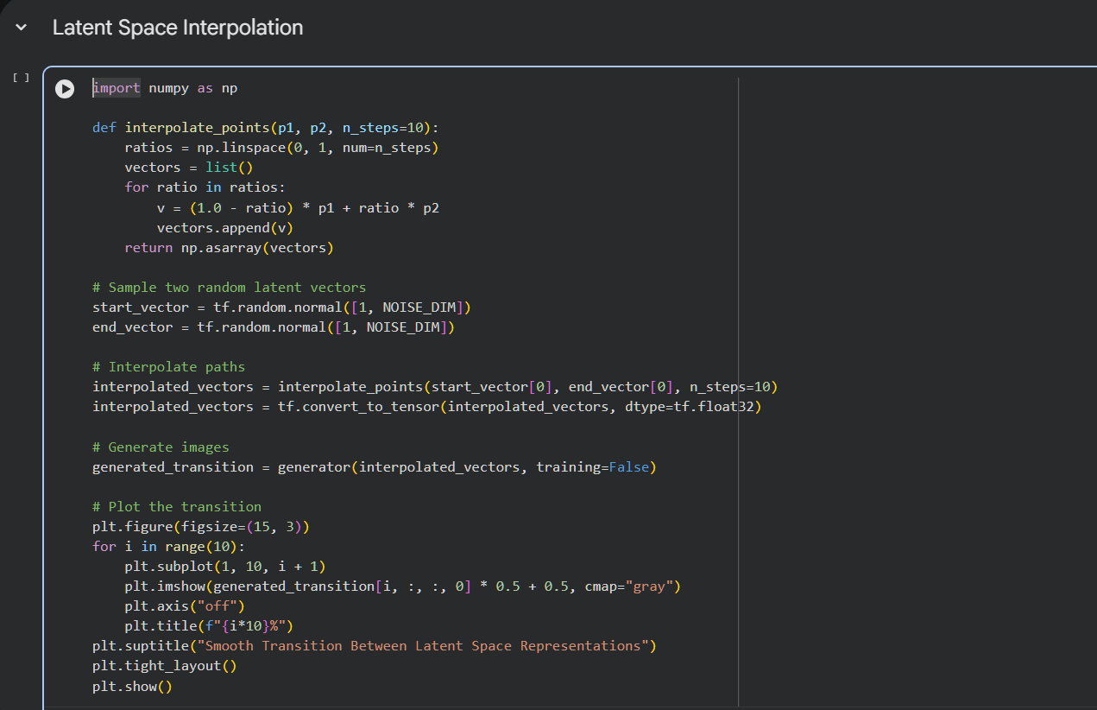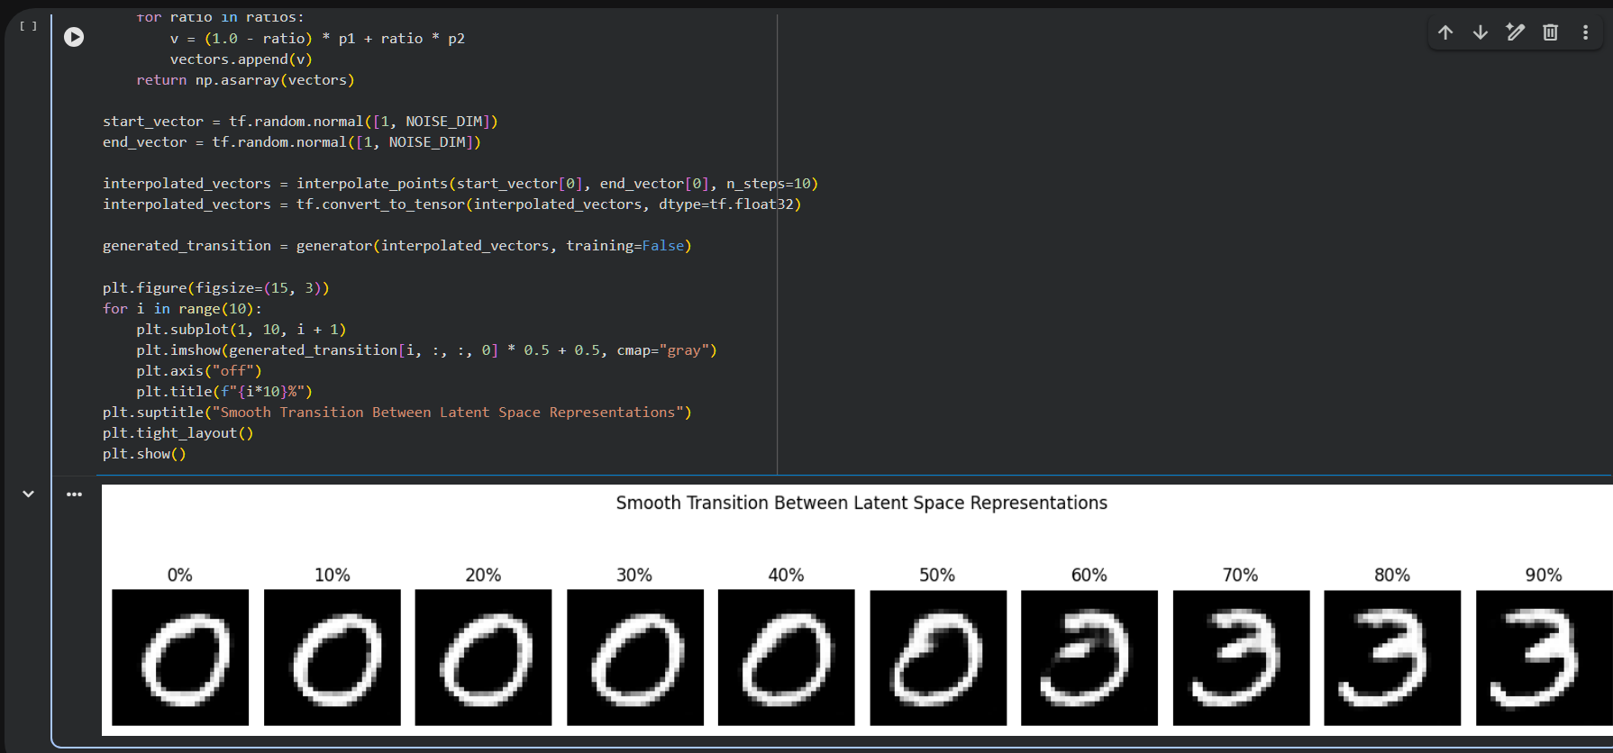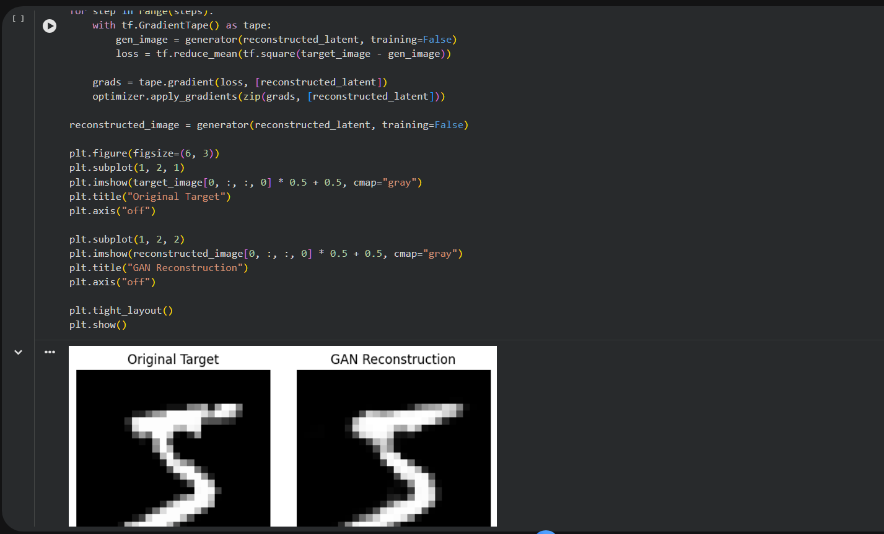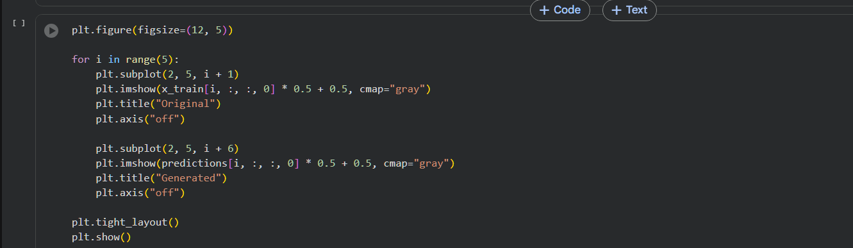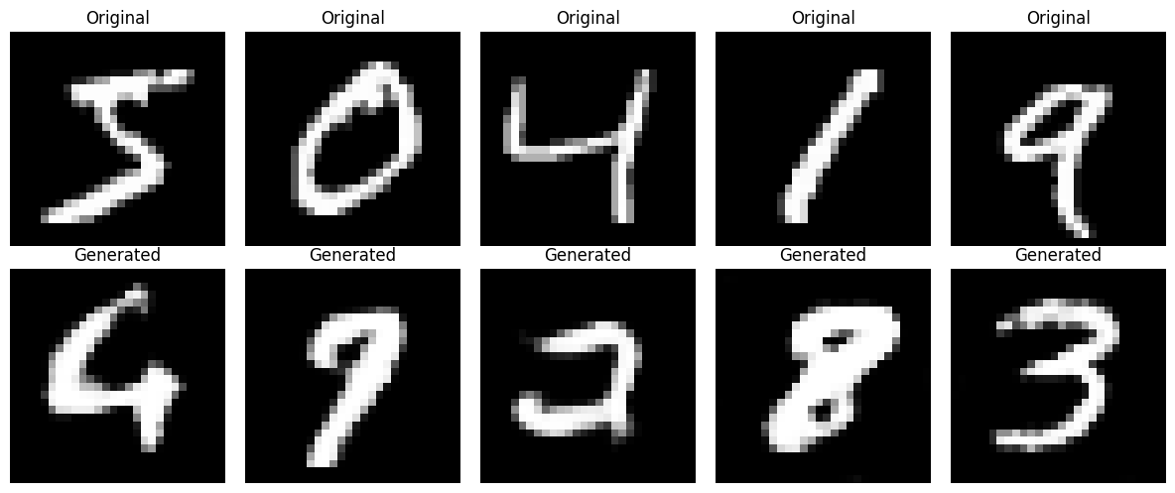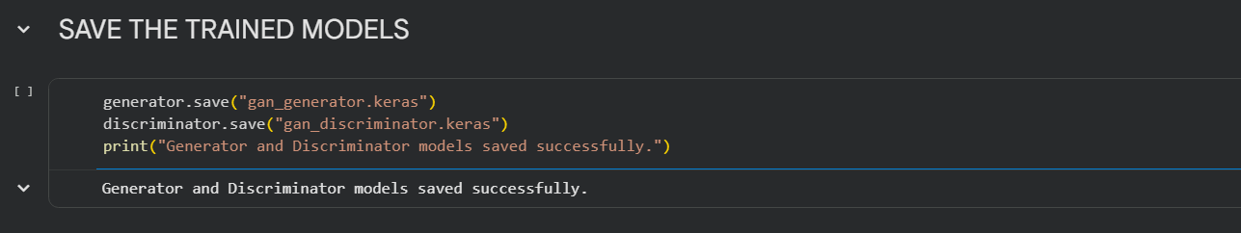

POST-LAB QUESTIONS

1. Discuss how the quality of generated images changes as GAN training progresses. Explain why a GAN may generate repetitive or low-quality images.

During the initial stages of training, GANs usually generate unclear and random images. As training progresses, the Generator learns patterns and produces more realistic images. However, GANs may generate repetitive images due to a problem called mode collapse. Unbalanced training between the Generator and Discriminator can also reduce image quality. Proper training, suitable learning rates, and sufficient data help improve image quality and diversity.

2. Differentiate between the Generator loss and the Discriminator loss.

Generator loss measures how unsuccessfully the Generator fools the Discriminator. A lower Generator loss generally indicates that generated images are more successful at being classified as real. Discriminator loss measures the error in identifying real and fake images. A lower Discriminator loss indicates better classification performance. Both losses are important for monitoring and balancing GAN training.

3. Discuss two real-world applications of GANs apart from handwritten digit generation.

GANs are widely used in medical imaging to generate artificial medical images for research and training purposes. They can help improve image quality and support medical image reconstruction. Another important application is image-to-image translation, where GANs convert images from one style or domain into another. For example, they can transform sketches into realistic images. GANs are also useful in image enhancement, restoration, and creative content generation.

ASSESSMENT
Description | Max Marks | Marks Awarded
Pre Lab Exercise | 5
In Lab Exercise | 10
Post Lab Exercise | 5
Viva | 10
Total | 30
Faculty Signature

